Two Threads Studio
Product Opportunity & Profitability Report
Based on current home décor, gifting, handcrafted, and sustainable lifestyle trends, this report identifies four promising product categories for Two Threads Studio:
- Lippan Art Décor
- Crochet Handmade Products
- Macramé Home Décor
- Luxury Scented Candles ( optional)
- Hnadmade Dolls
- handmade bouquet
- Handbags for womens
These products require relatively low initial investment, offer attractive profit margins, and align well with the growing demand for handmade and artisanal products.

- Lippan Art
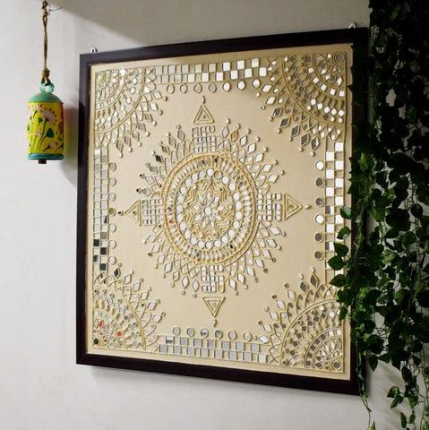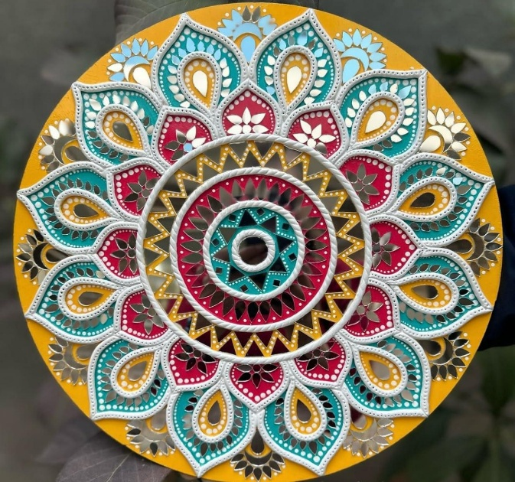

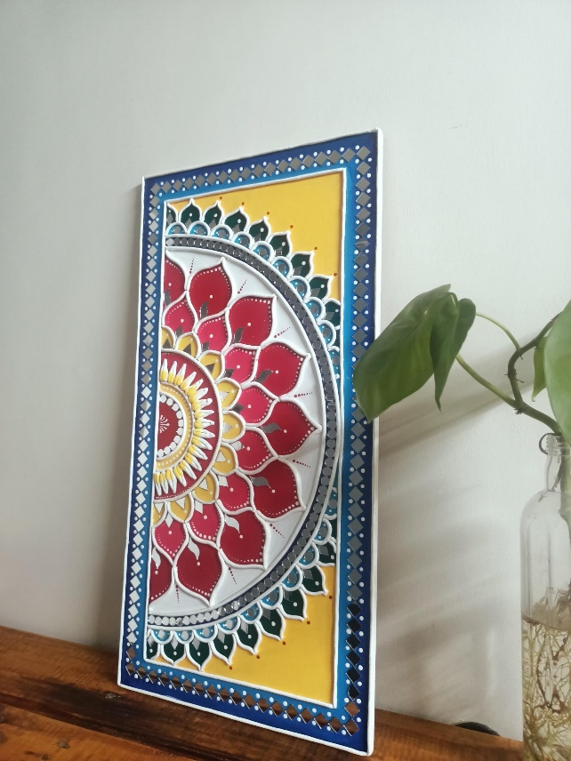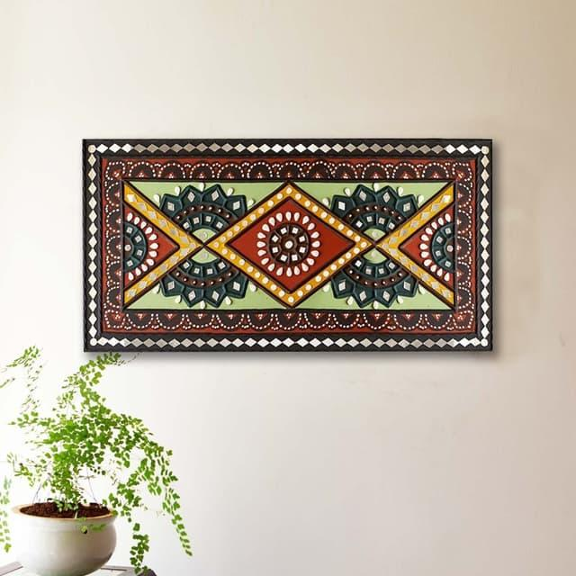

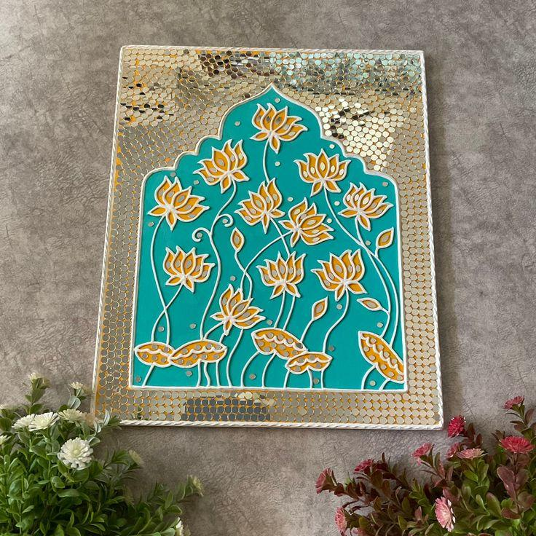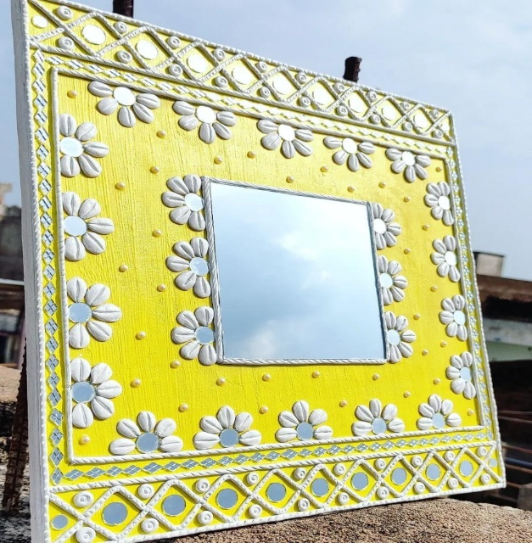

Categories to sell
Home Décor & Wall Art
1. Lippan Art Wall Frame
Average Selling Price: ₹1,200 – ₹3,500
Estimated Making Cost: ₹400 – ₹1,200
Expected Profit: ₹800 – ₹2,300
Profit Margin: 60–70%

2. Lippan Art Name Plate
Average Selling Price: ₹800 – ₹2,000
Estimated Making Cost: ₹250 – ₹700
Expected Profit Margin: 55–65%

3. Lippan Art Decorative Mirror
Average Selling Price: ₹1,500 – ₹5,000
Estimated Making Cost: ₹600 – ₹1,800
Expected Profit Margin: 60–70%

4. Lippan Art Mandala Wall Panel
Average Selling Price: ₹2,000 – ₹8,000
Estimated Making Cost: ₹700 – ₹2,500
Expected Profit Margin: 65–75%

Why It Has Potential
- Strong demand in modern interior décor
- Popular on Instagram and Pinterest
- Ideal for housewarming gifts
- Customization opportunities

- CROCHET PRODUCT COLLECTION
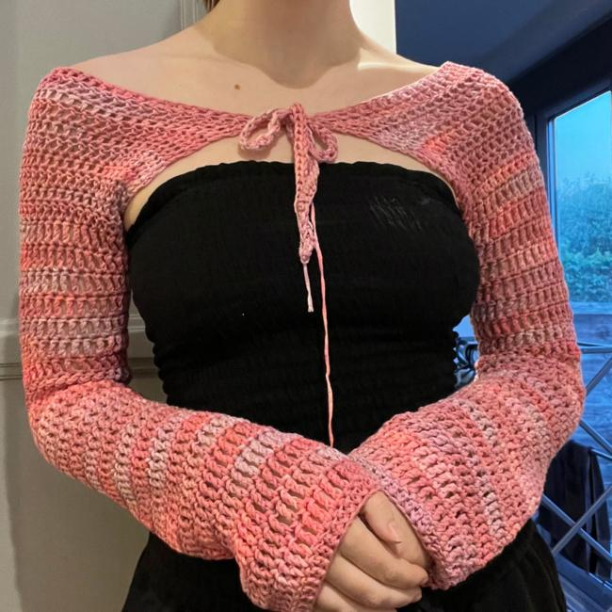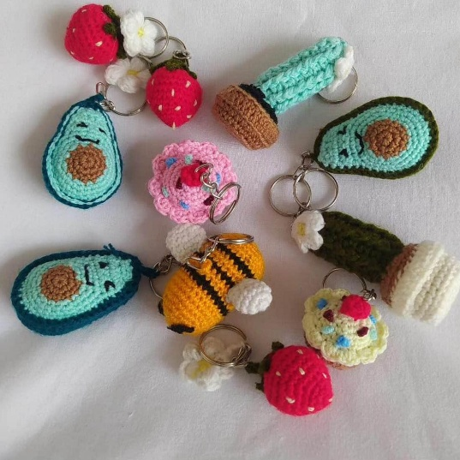
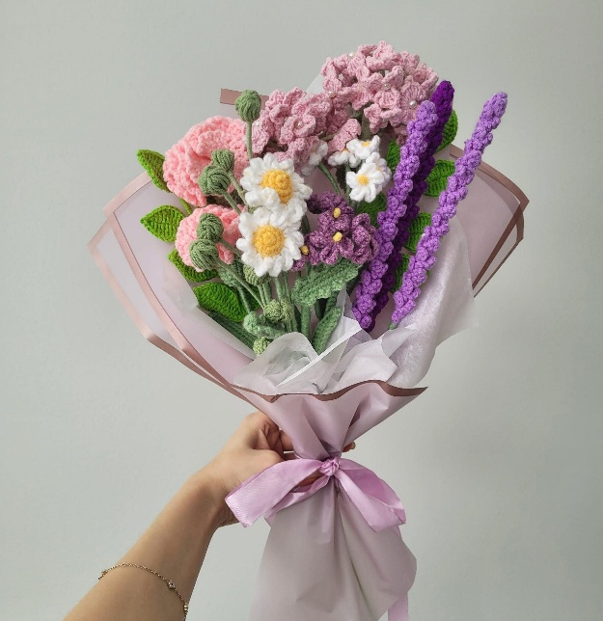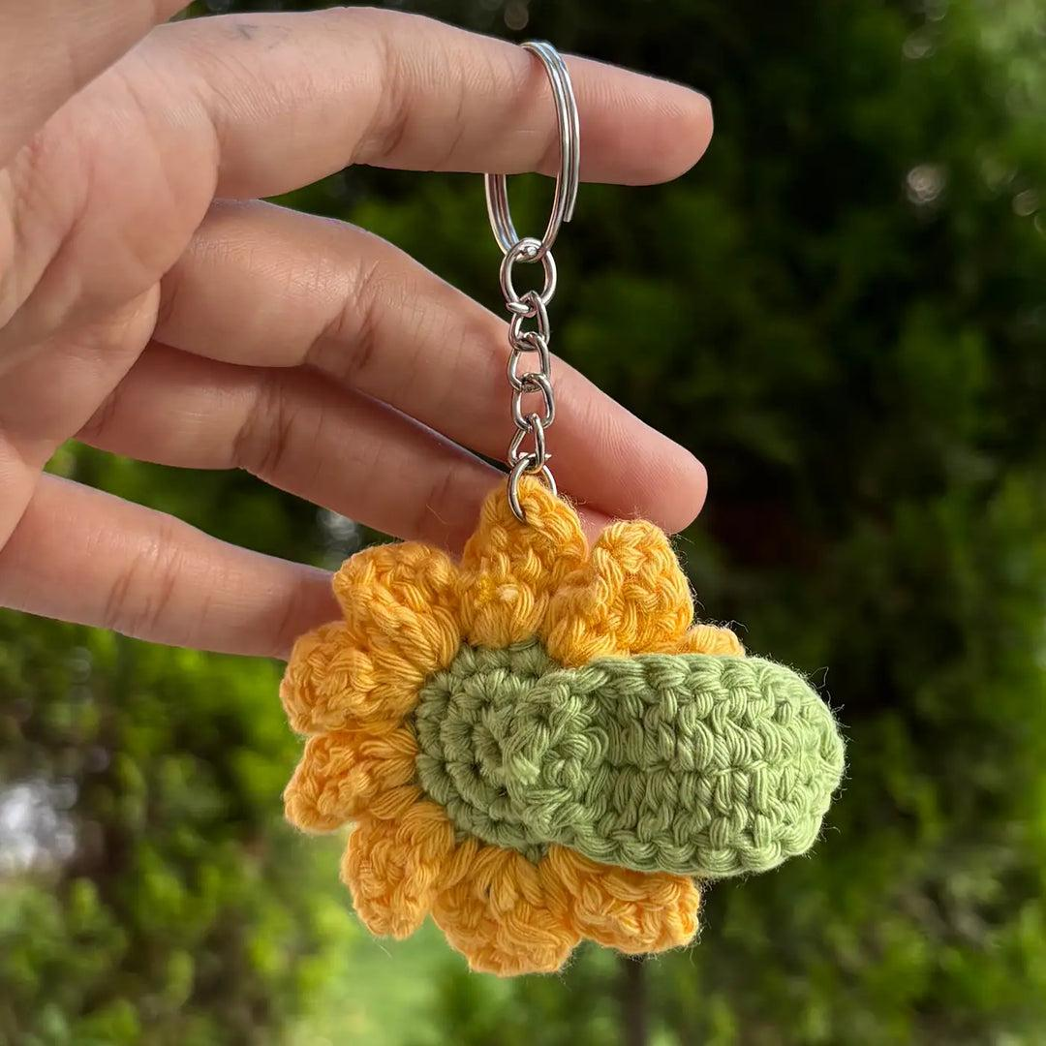
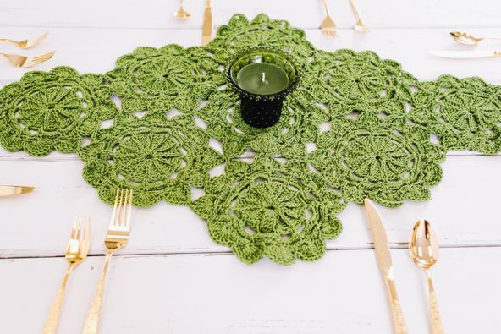

Category
Fashion Accessories & Handmade Gifts
1. Crochet Keychains
Average Selling Price: ₹150 – ₹500
Estimated Cost: ₹40 – ₹120
Profit Margin: 60–75%

2. Crochet Flower Bouquets
Average Selling Price: ₹500 – ₹2,500
Estimated Cost: ₹150 – ₹800
Profit Margin: 60–70%

3. Crochet Table Runners
Average Selling Price: ₹800 – ₹3,000
Estimated Cost: ₹250 – ₹1,000
Profit Margin: 55–65%

4. Crochet Shrugs
Average Selling Price: ₹1,500 – ₹4,000
Estimated Cost: ₹500 – ₹1,500
Profit Margin: 55–65%

5. Crochet Jackets
Average Selling Price: ₹2,500 – ₹8,000
Estimated Cost: ₹900 – ₹3,000
Profit Margin: 55–70%

6. Crochet Coasters
Average Selling Price: ₹300 – ₹900
Estimated Cost: ₹80 – ₹250
Profit Margin: 65–75%

Why It Has Potential
- Trending gifting product
- Handmade and premium appeal
- Easy customization
- Suitable for online sales
- MACRAME COLLECTION
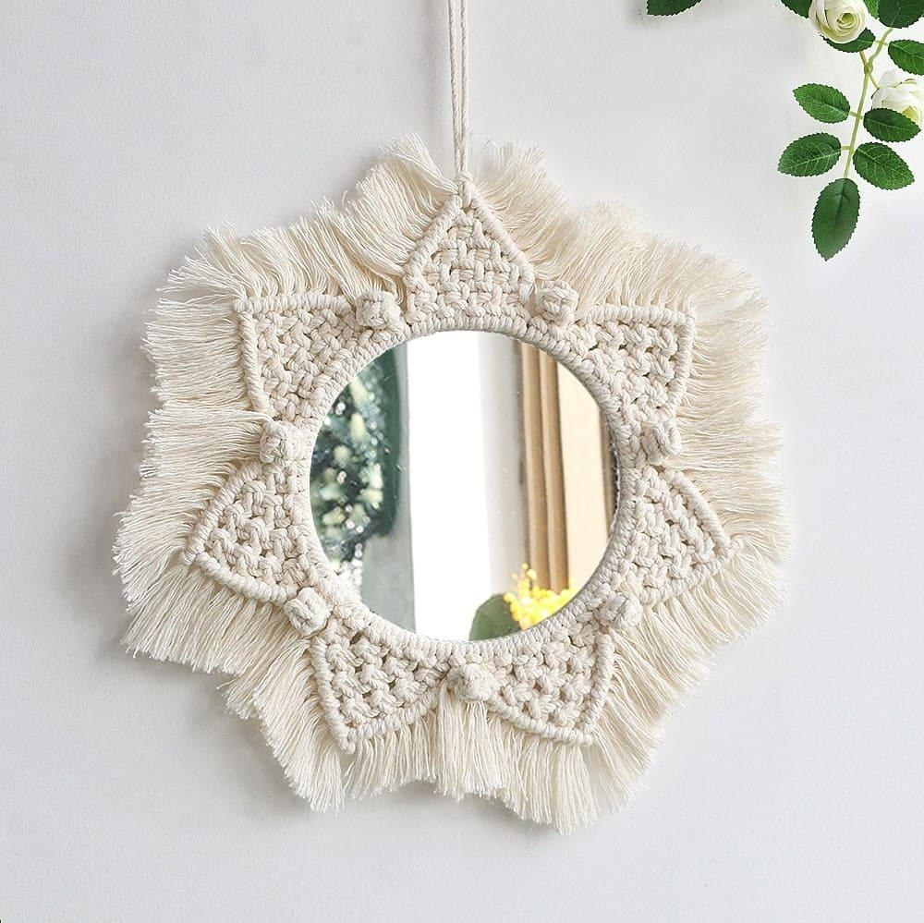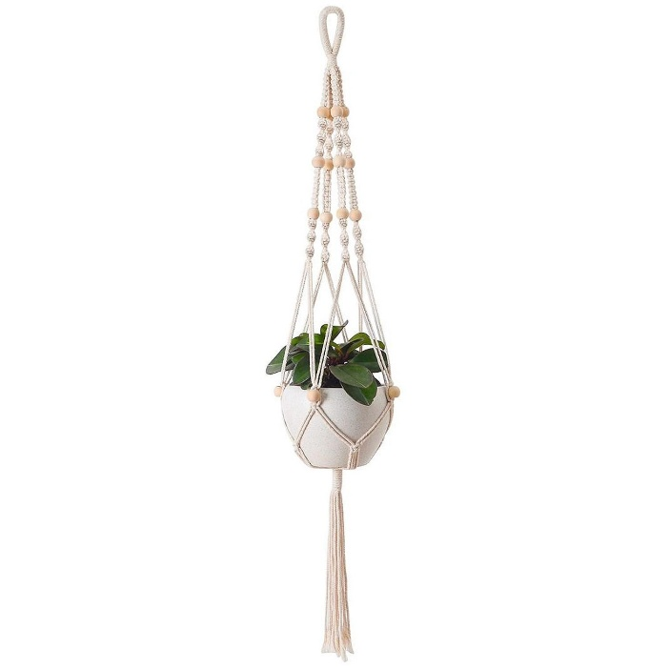
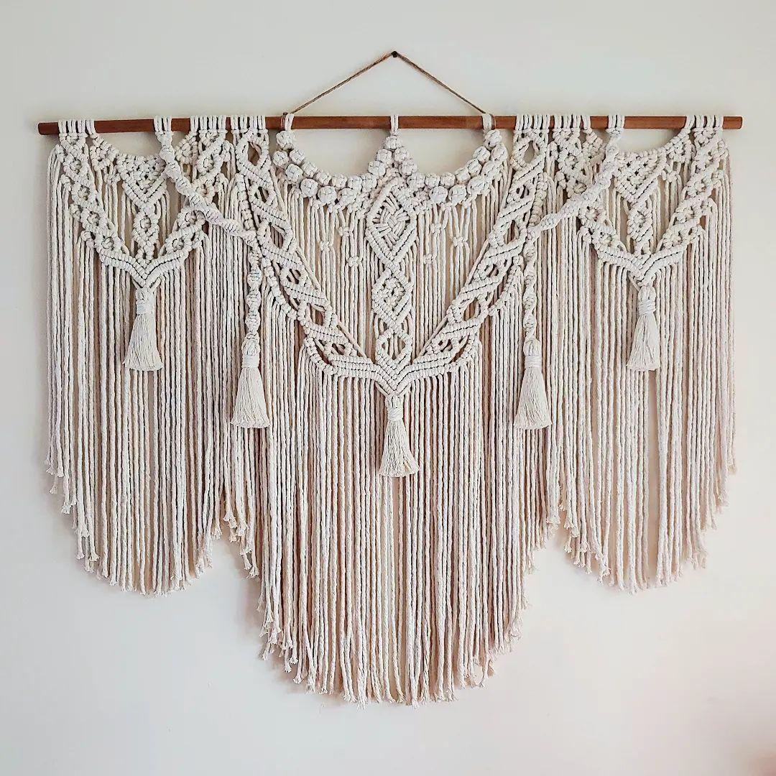
Categories
1. Macramé Mirror
Average Selling Price: ₹1,000 – ₹4,000
Estimated Cost: ₹300 – ₹1,200
Profit Margin: 60–70%

2. Macramé Wall Hanging
Average Selling Price: ₹700 – ₹3,500
Estimated Cost: ₹250 – ₹1,000
Profit Margin: 60–70%

3. Macramé Plant Hanger
Average Selling Price: ₹400 – ₹1,500
Estimated Cost: ₹120 – ₹500
Profit Margin: 60–70%

4. Macramé Shelf Décor
Average Selling Price: ₹1,500 – ₹5,000
Estimated Cost: ₹500 – ₹1,800
Profit Margin: 60–65%

Why It Has Potential
- Highly aesthetic and Instagram-friendly
- Popular among interior designers
- Strong demand in urban markets
- Excellent gifting product
- LUXURY SCENTED CANDLE COLLECTION
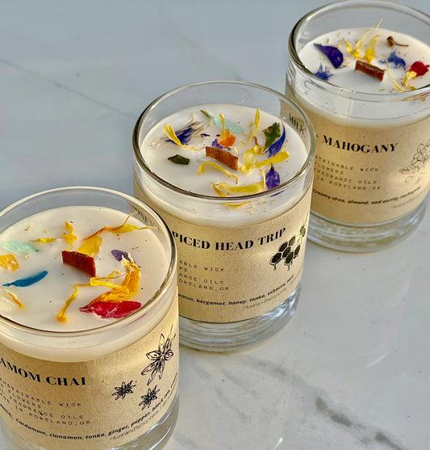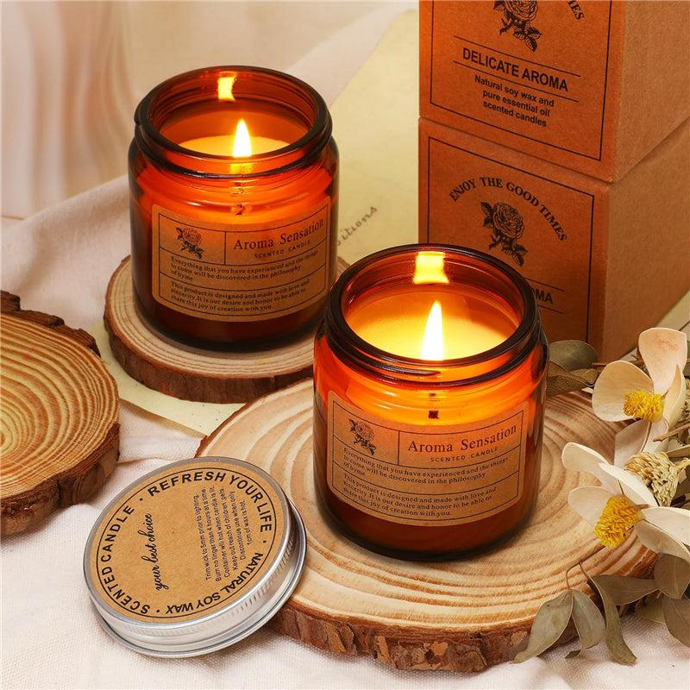

Categories
Lifestyle, Wellness & Hospitality
1. Soy Wax Candle
Average Selling Price: ₹400 – ₹1,200
Estimated Cost: ₹120 – ₹400
Profit Margin: 60–70%

2. Aromatherapy Candle
Average Selling Price: ₹500 – ₹1,500
Estimated Cost: ₹150 – ₹500
Profit Margin: 60–70%

3. Luxury Gift Candle Set
Average Selling Price: ₹1,000 – ₹3,500
Estimated Cost: ₹350 – ₹1,200
Profit Margin: 60–70%

4. Hotel & Spa Bulk Candle Packs
Average Selling Price: ₹150 – ₹400 per candle
Estimated Cost: ₹50 – ₹120
Profit Margin: 50–65%

Why It Has Potential
- Growing wellness market
- Corporate gifting opportunities
- Recurring purchase potential
- Hotel and spa partnerships

The handcrafted product market continues to grow as consumers increasingly value unique, artistic, and sustainable products over mass-produced alternatives. Lippan Art, Crochet Products, Macramé Décor, and Luxury Scented Candles present strong opportunities for Two Threads Studio due to their attractive profit margins, customization potential, and alignment with modern décor and gifting trends.
Prepared By: Shreyasi Sahoo
Position: CEO
Prepared For: Two Threads Studio
Date: June 2026

